**CO-CONSTRUCT ESTIMATOR**

***By***

**Muhammad Shawaiz CIIT/FA17-BCS-017/ATK**

**Saad Ahmed CIIT/FA17-BCS-056/ATK**

***Supervised By***

**Mr. Armughan Ali**



**COMSATS University Islamabad**

**Attock Campus - Pakistan**

**Bachelor of Science in Computer Science 2016-2020**

**COMSATS University Islamabad, Pakistan**

**CO-CONSTRUCT ESTIMATOR**

**A project presented to**

**COMSATS University Islamabad, Attock Campus**

**In partial fulfilment**

**of the requirement for the degree of**

***Bachelor of Science in Computer Science (2016-2020)***

**By**

**Muhammad Shawaiz CIIT/FA17-BCS-017/ATK**

**Saad Ahmed CIIT/FA17-BCS-056/ATK**

**COMSATS University Islamabad**

**Attock Campus – Pakistan**

|  |  |  |  |  |  |
| --- | --- | --- | --- | --- | --- |
| |  |  | | --- | --- | | **PROJECT ID** |  | | |  |  | | --- | --- | | **NUMBER OF MEMBERS** | 2 | |

|  |  |
| --- | --- |
| **TITLE** | CO-CONSTRUCT ESTIMATOR |

|  |  |
| --- | --- |
| **SUPERVISOR NAME** | Mr. Armughan Ali |

|  |  |  |
| --- | --- | --- |
| **MEMBER NAME** | **REG. NO.** | **EMAIL ADDRESS** |
| Muhammad Shawaiz | FA17-BCS-017 | shawaix017@gmail.com |
| Saad Ahmed | FA17- BCS-056 | Johnpaidu7862@gmail.com |
|  |  |  |

**MEMBERS’ SIGNATURES**

Supervisor’s Signature

**DECLARATION**

*We hereby declare that this software, neither whole nor as a part has been copied out from any source. It is further declared that we have developed this software and accompanied report entirely on the basis of our personal efforts. If any part of this project is proved to be copied out from any source or found to be reproduction of some other. We will stand by the consequences. No Portion of the work presented has been submitted of any application for any other degree or qualification of this or any other university or institute of learning.*

|  |  |
| --- | --- |
| Muhammad Shawaiz | Saad Ahmed |
| -------------------------------------- | ---------------------------------- |

**CERTIFICATE OF APPROVAL**

It is to certify that the final year project of BS (CS) “Project title” was developed by **Muhammad**

**Shawaiz (CIIT/FA17-BCS-017)** and **Saad Ahmed (CIIT/FA17-BCS-056)** under the supervision of **Mr. Armughan Ali** that in their opinion, it is fully adequate, in scope and quality for the degree of Bachelors of Science in Computer Sciences.

**Supervisor**

Mr. Armughan Ali

Assistant Professor

CUI Attock Campus

---------------------------------------

**Table of Contents**

1. Introduction 1

1.1. Brief 2

1.2. Relevance to course modules 2

1.2.1 Report Writing Skills (RWS………………………………………………………………3

1.2.2Mobile Application Development…………………………………………………………3

1.2.3Machine Learning…………………………………………………………………………3

1.2.4Human Computer Interaction……………………………………………………………...3

1.2.5Software Engineering……………………………………………………………………...3

1.2.6Software Design And Architecture………………………………………………………..3

1.3. Project Background 3

1.4. Literature Review 4

1.5. Analysis from Literature Review 7

1.6. Methodology & Software Lifecycle 8

1.6.Rationale behind selecting this methodology……………………………………………...8

2. Problem Definition 10

2.1. Problem Statement 10

2.2. Deliverable and Development Requirements 10

2.1.1 Interface Design………………………………………………………………………….11

2.2.2 Training Model…………………………………………………………………………..11

2.2.3 Find Contractor………………………………………………………………………….11

2.3. Current System 11

3. Requirement Analysis 16

3.1. Use Case Diagram 17

3.2. Detailed Use Case 19

3.3. Functional Requirements 21

3.4. Non-Functional Requirements 22

3.4.1 Performance……………………………………………………………………………...22

3.4.2 Availability………………………………………………………………………………22

3.4.3 Capacity………………………………………………………………………………….22

3.4.4 User Friendly…………………………………………………………………………….22

3.4.5 Speed…………………………………………………………………………………….22

3.4.6 Security…………………………………………………………………………………..22

3.4.7 Modidiable……………………………………………………………………………….22

3.4.8 Maintainability…………………………………………………………………………...22

4.Design and Architecture……………………………………………………………………….23

4.1. System Architecture 24

4.2. Class Diagram 25

4.3 Activity Diagram…………………………………………………………………………….26

4.4. Design Models 28

4.4. Design Models 29

**List of Figures**

Figure 1.1. Construction Estimator Calculator……………………………………………………5

Figure 1.2. Construction Calculator………………………………………………………………6

Figure 1.3. Construction Estimator……………………………………………………………….7

Figure 2.1 Construction Estimator Calculator…………………………………………………...12

Figure 2.2 Construction Estimator Calculator…………………………………………………...12

Figure 2.3 Construction Calculator………………………………………………………………13

Figure 2.4 Construction Calculator………………………………………………………………13

Figure 2.5 Construction Estimator ………………………………………………………………14

Figure 3.1.1 Complete Use Case (User)…………………………………………………………17

Figure 3.1.2 Complete Use Case (Contractor)…………………………………………………...18

Figure 4.1 System Architecture………………………………………………………………….24

Figure 4.2 Class Diagram………………………………………………………………………..25

Figure 4.3.1 Activity Diagram (User)……………………………………………………………26

Figure 4.3.1 Activity Diagram (Contractor)……………………………………………………..27

Figure 4.4.1 Sequence Diagram (Contractor)……………………………………………………28

Figure 4.4.2 Sequence Diagram (User)………………………………………………………….29

**List Of Tables**

Table 2.1 Comparison with existing system……………………………………………………..15

Table 3.2.1 UC1- User Use Case………………………………………………………………...19

Table 3.2.2 UC2- Contractor Use Case………………………………………………………….19

Table 3.2.3 Make Estimate………………………………………………………………………20

Table 3.2.4 Find Contractor……………………………………………………………………...20

Table 3.2.5 User Use Case……………………………………………………………………….21

Table 3.3.1 FR-1………………………………………………………………………………....21

Table 3.3.1 FR-2…………………………………………………………………………………21

Table 3.3.1 FR-3…………………………………………………………………………………22

**Abstract**

In the last few years, the world has grown immensely, technology amendments and technology advancements have reshaped every field, and similar is the case with buildings and construction development. We are going to introduce an android based application that is going to work on estimated cost of a project. It is an android based application that will help especially customer’s , business owners, contractors, architects, engineers, and other professionals within the construction industry to give cost estimates to determine the labor & material expenses, overheads, and profit . It helps the user to check various construction materials and equipment’s i.e. (cement, iron, crush, labor, machinery etc.).It will also help in checking the feasibility of the construction project, getting a basic idea about how much would be the total cost of the project(estimated cost provided by the app) and ultimately deciding whether to go ahead with the project or not. This System will help us to eliminate the current problems and will be a big step toward the paperless environment deciding whether to go ahead with the project or not. This app will provide the user with nearest estimates against their construction requirements by taking parameters and giving educated estimated against those parameters. This app will also provide large scale estimations including house, balcony, rooms etc. The will also have a contractors end where they can make profile and provide necessary information and services according to their specialty and expertise. The user after getting the estimate can also have the option to find contractor by searching accordingly to the service they require. The app will give results according to their and gives suggestions of the best with respect to location, rates, specialty etc.

**Chapter 1**

**Introduction**

# Introduction

Many building contractors and construction business owners and the common person still rely on manual registers or excel spreadsheets. These manual methods of estimating the cost of a construction project or a building such as houses, apartments, flats etc. are assumed to be simple to master but fail to provide speed and accuracy. Manual handling is prone to errors and highly time-consuming. In addition to that, when it comes to sharing and making of the estimates at smaller or most probably at big project estimates, these manual methods can provide restricted facilities whereas through modern ways it is easier, better, faster and accurate.

Construction estimating application is a system that can streamline and automate the process of calculating estimate of a construction project's total expenditures. It automates the processes of making an estimate. The use of construction estimating app can help in improving accuracy, speed, and productivity. Also from this app users can get proper estimates based on the algorithm accordingly to it. Beside this, there are features included that will provide ease to the users to find the contractors that fits to their requirements with respect to the labor cost, overall rates (including the machinery) etc. On the other hand contractors also have their profiles where they put all of their information including their work and field expertise their rates in contexts of different building types etc.

In our app, we will provide ease for both user end as well as the contractor’s end. Both the user and customer will have to properly login through valid e-mail, username and password, after logging in the user will jump to the dashboard and can make estimates according to the parameters required and the app will respond according to the parameters provided by the user and give the nearest estimated cost. On the other hand, the contractor will have to fill some extra requirements by giving specialty, location, rates etc. The user after making the estimates can find the contractor just at a click and by entering the requirements the user can find the find the suggestions of the contractors according to the query and can select the best out of those with respect to the price, location and specialty.

## Brief

The purpose of this project is to make an android app that provides to the user’s ease who does not have any experience and idea in construction field, does not know in the making of cost estimates and so face problems when it comes to construction processes including houses, walls, stairs, flooring, balcony and offices etc. However, most of the customers having no experience regarding cost of any construction process are rigged and fooled by the contractor or other authorities such as private construction industries or companies. This construction estimator app will ultimately overcome the cost problems to user’s having no idea construction matters. Moreover, before starting any construction process they already have an idea that how much will be the cost of their desired construction procedure according to their needs and requirements. This will ultimately cut off the consequences of being fooled of rigged by the construction authorities.

Android studio platform will be used in order to design and implement the construction estimator application using core Java concepts and Android Studio. Also Firebase database will be used to store and the information of the users and contractors. The users and contractors both have to register properly through their e-mail ids, unique username and a secured password. By registering into the app, the user and contractor both get their unique profiles with their provided information, now they can use the app functionalities by enabling to dashboard and also at any instance, both users and contractors can update and modify their information according to their own desire and for security. There are some other requirements including i.e. some legit information of their work specialty, their rates, labor cost, and overall cost of a project w.r.t the area defined etc. At last, some core Machine Learning approach and techniques will be used to improve the performance and compatibility of the application.

Later on, in next chapters, we will discuss about the problem statement, solution & requirements, and diagrams related to our Project.

## Relevance to course modules

**1.2.1 Report Writing Skills (RWS):**  through which we are able to write our documentation, able to know how to select format and structure to meet formal needs, ensuring that document sequence is logical, meaningful and presentable. Presenting information differently through text, graphs, tables and diagrams.

**1.2.2 Mobile App Development:** is the core subject of CS regarding the development of mobile apps through which we are able to design and develop this app. This course helps us to cope up with the various issue and features of app development.

**1.2.3 Machine Learning:** is one of the main subject through which we are able to apply different techniques and algorithms to classify the data, extract required results from this classification and achieve accuracy.

1.2.4 Human computer interaction: is a multidisciplinary field of study that focuses on thedesign of computer and technology and especially interaction between human and computers. The design principles to improve human interaction with computer. Through this subject, we are able to make interactive and user friendly interface.

1.2.5Software Engineering: helps us to start our final year project by 5 phases of software engineering i.e. requirement gathering, design, implementation, testing and maintenance. Different types of software models we have learn helps to decide which software model is to be used in our project according to our requirements.eg water fall, agile, spiral etc.

1.2.6Software Design and Architecture: enables us to learn the Unified Modeling Language Diagrams. How to design a software system based on requirement. This course helps in our project that how to design a system. We learn following diagram from this course.

* Activity Diagram
* Use Case Diagram
* Sequence Diagram
* Class Diagram
* Communication Diagram

## 1.3. Project Background

We are developing and android app in which the users can get the nearest estimate of the cost required for any construction project type according to the requirements of the user in context of the price, material required, labor etc. In this app, the users also have the option to select the contractors from the app for their construction needs. The user has to search the key word to find the services they want. This app will provide the filtered profiles according to the search, so that the buyer does not suffer a lot.

Let’s suppose that a customer wants to build a house and wants an estimated cost required to build the house according to the parameters he/she enters. The app will provide an estimate according to the parameters they enter. After the user gets an estimate, the user will also have the choice to find right person for the job if he/she wants to with respect to their overall rates, labor, machinery and material cost etc. They just have to search accordingly to the service they require and give necessary requirements and enter, the filtered results against their search will be provided with the contractor’s profiles where they can have the choice to choose the service provider according to their needs without third party interference. This will also cut off the risk of being rigged by the third party. Also this app will provide the users with the facility to ovoid cost overflow.

## 1.4. Literature Review

Most construction system lacks the small aspects of estimations and just focus on the overall estimation neglecting the small construction requirements e.g. walls, floor, roofing, etc. There are certain apps that provide some estimations but does not provide small scale estimation needed for temporary purpose. These types of apps does not facilitates most user because it does not covers the real world daily life requirements related to the construction. Also these apps does not provide the facility to user as well as contractors to make profile and get updated and to make updates time to time by updating the profile, services etc.

Following are some of the apps related to our project but these apps do not aimed to provide user ease to find the right person for the job, also it does not facilitate the user to make large scale estimation e.g. house, balcony, roof etc. Also these apps does not have any login/sign up activities, here the user just installs the app from the play store and make estimation according to very limited resources provided on the app main and the calculations are formula based, the user does not know on which basis the app is giving the results, either it’s according to existing prices or of the time when it’s built.

* **Construction Estimator Calculator:**

Construction Estimator Calculator app’s aim is to provide user to make small scale construction estimations i.e. slab, stairs, plaster, walls etc.

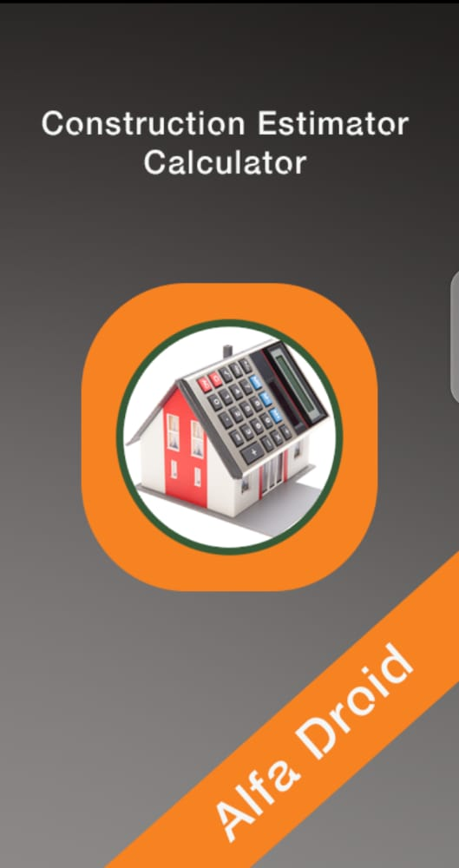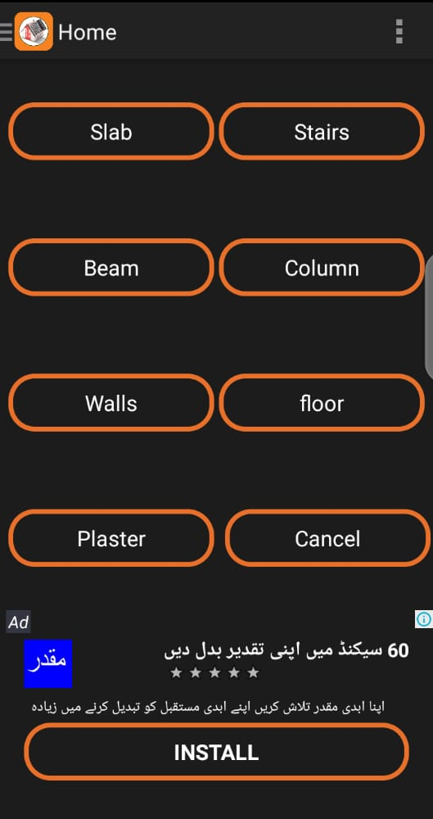

**Figure 1.1: Construction Estimator Calculator**

**Features:**

* Small scale estimations
* Slab
* Beam
* Walls
* Floor
* Plaster

**Construction Calculator:**

The construction app is present on the play store that also provide construction estimation facilities to the users. In this app, the user can make estimations just like the previous defined apps including some extra features that makes it better from the previous app which includes features like concrete estimation, tiles, plaster, blocks, slabs steel etc.

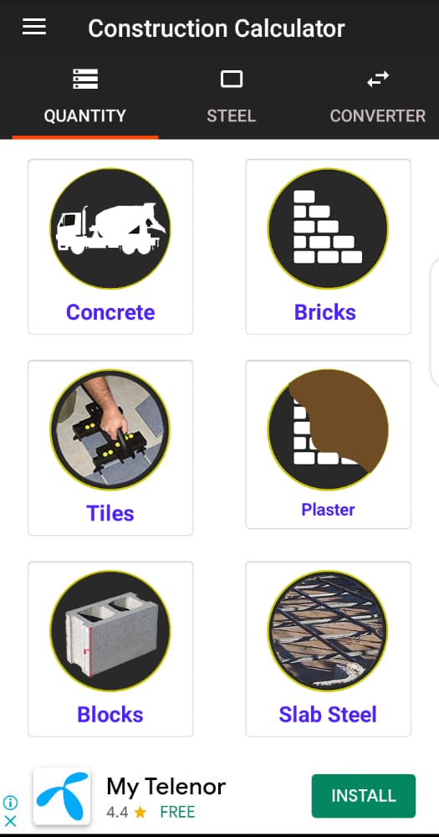

**Figure 1.2: Construction Calculator**

**Features:**

* Concrete estimation
* Bricks
* Plaster
* Tiles
* Blocks
* Slab Steel

**Construction Estimator:**

The construction estimator is the simplest and the basics of apps available in the paly store in context of making construction material estimations. Having the simplest of the user interface and features.

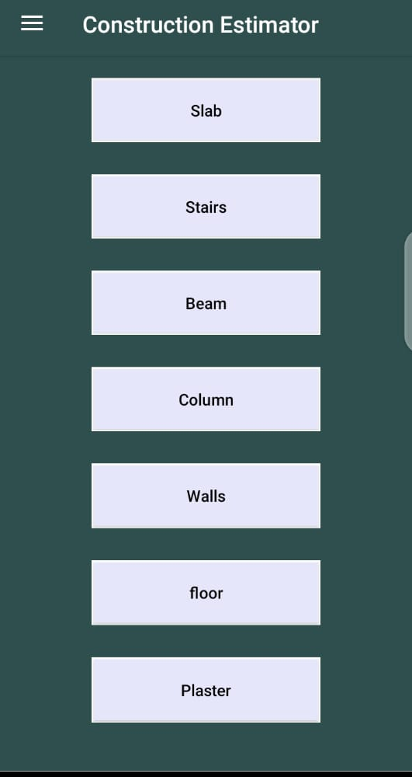

**Figure 1.3: Construction Estimator**

**Features:**

* **Slab**
* **Stairs**
* **Beam**
* **Column**
* **Walls**
* **Floor**
* **Plaster**

## 1.5. Analysis from Literature Review

The concept of our project is already been developed in Industry, but not yet created at FYP Level. Also, we are adding some new features like,

* Adding features to facilitate both user and the contractor
* Proper interface design with complete login/sign up activity
* Provide small scale estimations to user i.e. walls, floor, roof etc.
* Provide the estimates based on the material cost ( based on the quality of material)
* Provides option to find the best person for the project
* Provides the best available contractor for the job according to needs.
* Large scale estimation on the basis of given parameters

This will makes easier for the users to get best estimates and contractors allowing them to communicate and decide what to do and fix the cost collaboratively for the project.

## 1.6. Methodology & Software Lifecycle

Developing a cost estimation app with some modern features is not an easy task. We need to test the models and checking for error is done again and again. Software Development Lifecycle for this project is Iterative Model. We will start from developing and designing of the user interface, and then adding some common features to it that are necessary requirements. Then, we will be designing and implementation of the main app feature the estimation where the user can estimate according to the needs and requirements. At the same working on the app’s responsiveness to improve user and contractors interactions on the app, also including the feature for the user to find contractor according to his requirements. At the end we will be applying Machine Learning techniques to work on the estimations based on the set of datasets provided to make estimates closest to the required cost .

#### 1.6.1. Rationale behind selecting this Methodology

The reason behind selecting this methodology and SDLC is that the Iterative model works on repetition of processes. As we don’t know about the complete requirements, so we will work on set of software requirements, then test, evaluate and identify further requirements according to our need. At each iteration the software will have something new in it. We will repeat until our project is ready.

**Chapter 2**

**Problem Definition**

# 2. Problem Definition

In this Chapter we will discuss about the problem statement in current system and relate them to the solution provided by our project.

## 2.1. Problem Statement

Many building contractors and construction business owners and the common person still rely on manual registers or excel spreadsheets. These manual methods of estimating the cost of a construction project or a building such as houses, apartments, flats etc. are assumed to be simple to master but fail to provide speed and accuracy. Manual handling is prone to errors and highly time-consuming. In addition to that, when it comes to sharing information, collaborating and communicating with the team, these manual methods can provide restricted facilities. Also there is a factor that most people do not have much knowledge regarding construction, what should be the cost for doing a specific construction project i.e. building a house, roof, wall, stairs etc. What type of material is required, their rates, what should be the labor cost for doing a specific task like building a house etc. Due to lack of knowledge most of the time customers and scammed by the contractors or some companies in the context of material, labor and machinery ultimately resulting in overflow of cost of a project and sometimes results abandoned of a project.

Co-Construct Estimation app will overcome these issues and also provides users ease to find the right person for the job if they want to. Also provides users the knowledge about the materials and their market rates with respect to the present situations that surely will cut off the scam ratio done by contractors and companies to the customers because the user already haves the knowledge about the material, it’s quality and rates.

## 2.2. Deliverable and Development Requirements

Requirements are important part of software development. Before starting a project, requirements are gathered, to formulate and manage the designing phase.

#### 2.2.1. Interface Design

#### Making the user interface is essential part of project. For that purpose, advanced responsive and attractive interface will be designed using Android Studio and Java.

#### 2.2.2. Training Model

#### Making educated and nearest exact estimates is not an easy task, dataset and machine learning algorithms are required to train models accordingly.

#### 2.2.3. Find Contractor

#### The user will be provided ease to find and search the contractor according to the specific needs and requirements.

## 2.3. Current System

Construction Estimator Calculator, Construction Calculator, Construction Estimator and similar kinds of apps exists on the play store available for android users. These apps provides the user to small estimates like Slab, Stairs, Walls, Floor. Plaster and provides user to configure the rates. However, these apps does not provide users to make large estimates like calculation of the cost of building a house, a small room, etc. These apps also do not have the features to find the contractors just at a click according to their requirements also do not provoke user/contractor interaction.

**Construction Estimator Calculator:**

Construction Estimator Calculator app provides the small scale estimation like Stairs, Slab, Floor, Walls, Plaster, and also provides configuration settings. However, it does not allow the user to calculate large scale estimations like house, Rooms, Kitchen, Gallery, and Balcony.



**Figure 2.1: Construction Estimator Figure 2.2: Construction Estimator**

**Calculator Calculator**

**Construction Calculator:**

Construction Calculator app also works on similar concepts provided to the user in the previous app which provides with the similar kind of facilities and does not provide the facility to make large scale estimations and also does not have the property of finding the contractors or company.



**Figure 2.3: Construction Calculator**

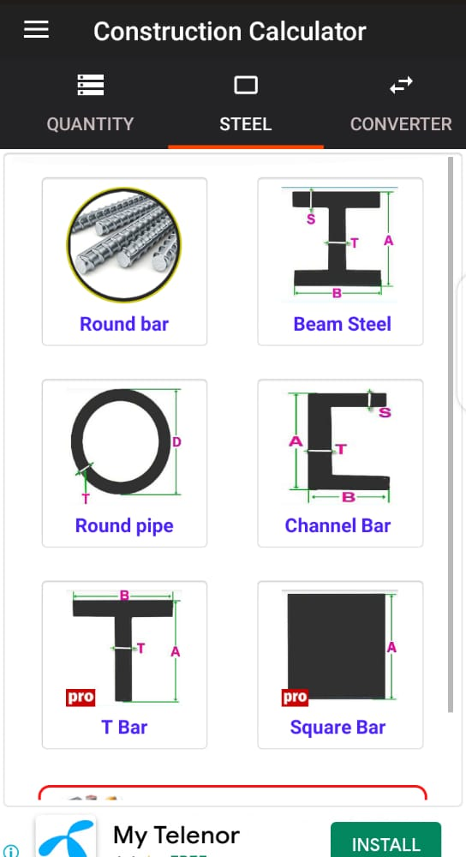

**Figure 2.4: Construction Calculator**

**Construction Estimator:**

Construction Estimator app is the simplest of apps on the play store and provides the user to make simplest of estimates based on the small scale construction requirements with the simplest of user interface.



**Figure 2.4: Construction Estimator**

#### Table 2.1: Comparison with other existing systems

#### 

|  |  |  |  |  |  |
| --- | --- | --- | --- | --- | --- |
| **Application** | **Plaster Estimate** | **Roof Estimate** | **Contractor Profile** | **Stairs Estimate** | **House Estimate** |
| **Construction Estimator Calculator** | Yes | No | No | Yes | No |
| **Construction**  **Calculator** | Yes | Yes | Yes | No | No |
| **Construction Estimator** | Yes | Yes | Yes | Yes | No |
| **Co-Construct Estimator** | Yes | Yes | Yes | Yes | Yes |

**Chapter 3**

**Requirement Analysis**

## 3.1. Use Case Diagram

**Figure 3.1.1. Complete System Use Case (User)**

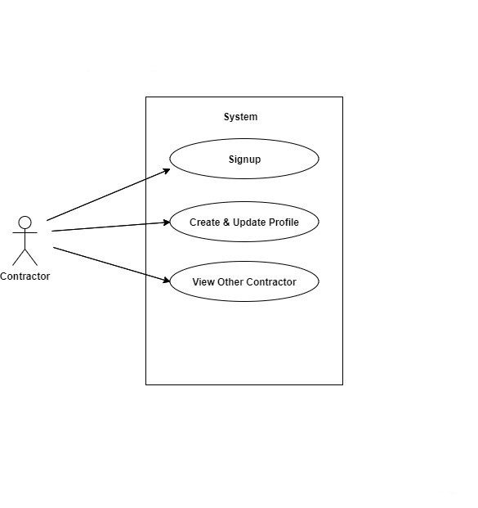

**Figure 3.1.2. Complete System Use Case (Contractor)**

## 3.2. Detailed Use Case

**Table 3.2.1 UC1- User Use case**

|  |  |
| --- | --- |
| **Use Case Name** | **Complete System Use Case (User)** |
| **Description** | User Signup/Login system to access the functionality of system |
| **Actor** | User |
| **Pre-Condition** | System must be connected to Internet |
| **Post-Condition** | Signup/Login successful notification will be displayed |

**Table 3.2.2 UC2- Contractor Use case**

|  |  |
| --- | --- |
| **Use Case Name** | **Complete System Use Case (Contractor)** |
| **Description** | An interface that enables contractor to sign up and log in to the app |
| **Actor** | Contractor |
| **Pre-Condition** | Contractor must be logged in |
| **Post-Condition** | Jumps directly to App interface |

**Table 3.2.3 Make Estimates**

|  |  |
| --- | --- |
| **Use Case Name** | **Make Estimates** |
| **Description** | Option to select the type to make estimates according to required parameters |
| **Actor** | User |
| **Pre-Condition** | User must be logged in |
| **Post-Condition** | Estimation interface will appear |

**Table 3.2.4 Find Contractor**

|  |  |
| --- | --- |
| **Use Case Name** | **Find Contractor** |
| **Description** | User will able to search and find contractors according to the required specialty. After making the estimates user will have pre-idea of the required cost and can find a good person for the job |
| **Actor** | User/Contractor |
| **Pre-Condition** | User must be Connected |
| **Post-Condition** | Interface will be displayed which provides the user to find according to requirement |

**Table 3.2.5 Contractor Profile**

|  |  |
| --- | --- |
| **Use Case Name** | **Register Contractor** |
| **Description** | The contractor can register and make profile where he gives description regarding rates, and expertise |
| **Actor** | Contractor |
| **Pre-Condition** | Contractor must be logged in |
| **Post-Condition** | A profile interface will be appeared |

## 3.3. Functional Requirements

Functional requirement is defined as sets of input, behavior and outputs. The functional requirement of any system is the specific behavior and functions of that system.

**Table 3.3.1 FR-1**

|  |  |
| --- | --- |
| **Name** | 3.3.1. FR-1: Register User |
| **Requirements** | User must be registered to access the functionality of system |
| **Dependencies** | N/A |
| **Priorities** | High |

**Table 3.3.2 FR-2**

|  |  |
| --- | --- |
| **Name** | 3.3.2. FR-2: Interface for both user/contractor |
| **Requirements** | Making a buyer/seller interface is important to set up the tone to find contractor and connect to respond |
| **Dependencies** | FR-1 |
| **Priorities** | High |

**Table 3.3.3 FR-3**

|  |  |
| --- | --- |
| **Name** | 3.3.4. FR-4: Training Model |
| **Requirements** | A related dataset will be required to train the algorithm to make estimations accurately and consistently |
| **Dependencies** | N/A |
| **Priorities** | High |

## 3.4. Non-Functional Requirements

Non-Functional requirement defines a function and its components.

#### 3.4.1. Performance

We are trying to achieve best performance for our app, but this project involves large scale calculations and training datasets, so it would affect efficiency.

**3.4.2. Availability**

Users can access the system anytime, anywhere.

#### 3.4.3. Capacity

The system will be able to operate function for the maximum time of the day. The system does not need to process too much data, so it is easy to process.

**3.4.4. User friendly**

Interface of our app will be easy to use so that a beginner can also use it quite easily.

**3.4.5. Speed**

The application must be robust and do not crash

**3.4.6. Security**

The system must be secure and the user integrity must not be at stake.

**3.4.7. Modifiable**

The system must have provisions for future additions and extra functionality.

**3.4.8. Maintainability:**

This app can easily be maintained

**Chapter 4**

**Design & Architecture**

## 4.1. System Architecture

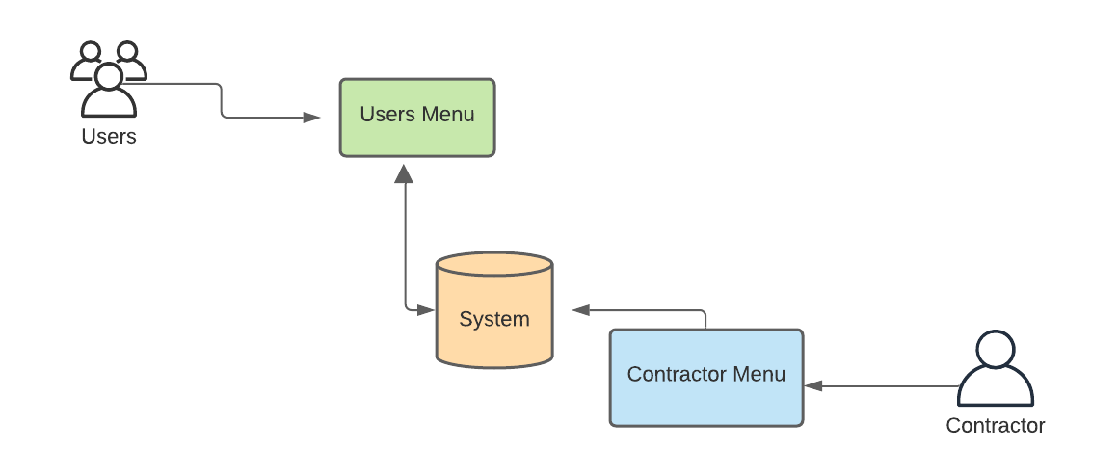

**Figure 4.1. System Architecture**

## 

## 4.2. Class Diagram

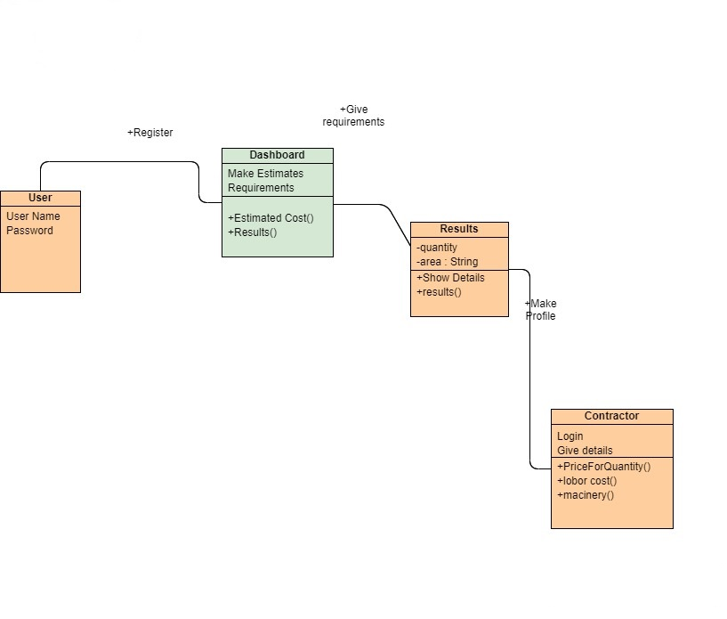

**Figure 4.2. Class Diagram**

**4.3. Process Flow / Representation**

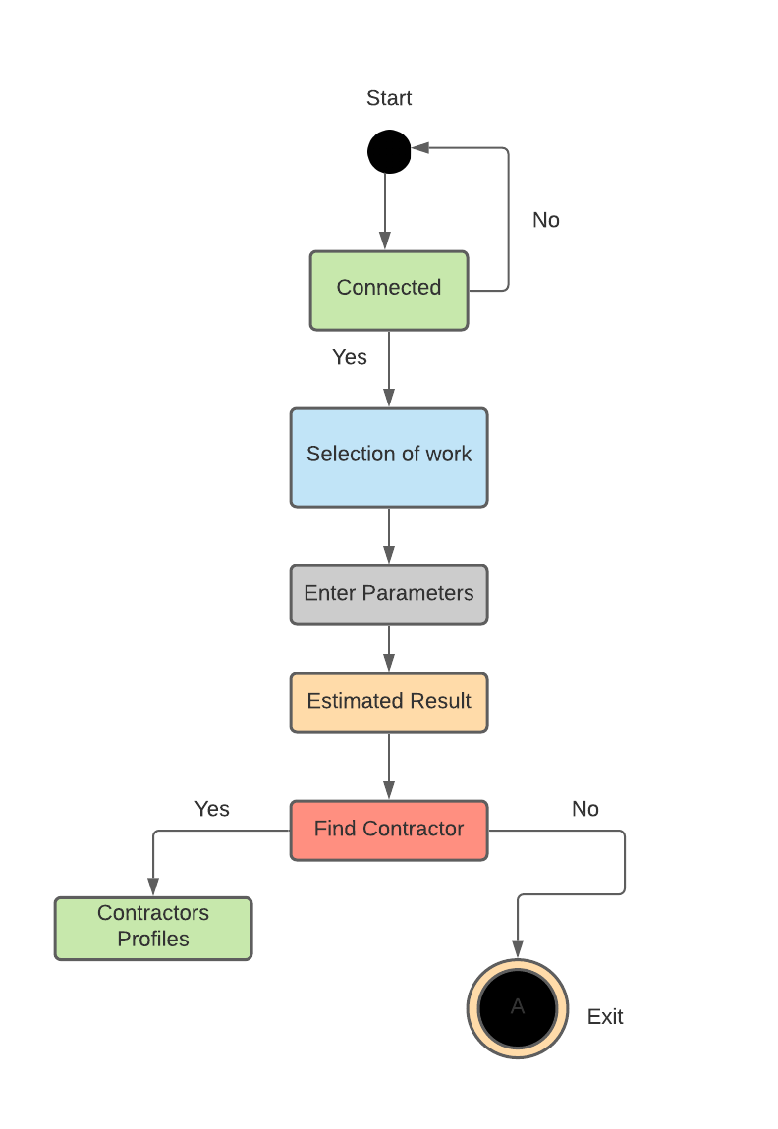

**Figure 4.3.1. Activity Diagram (User)**

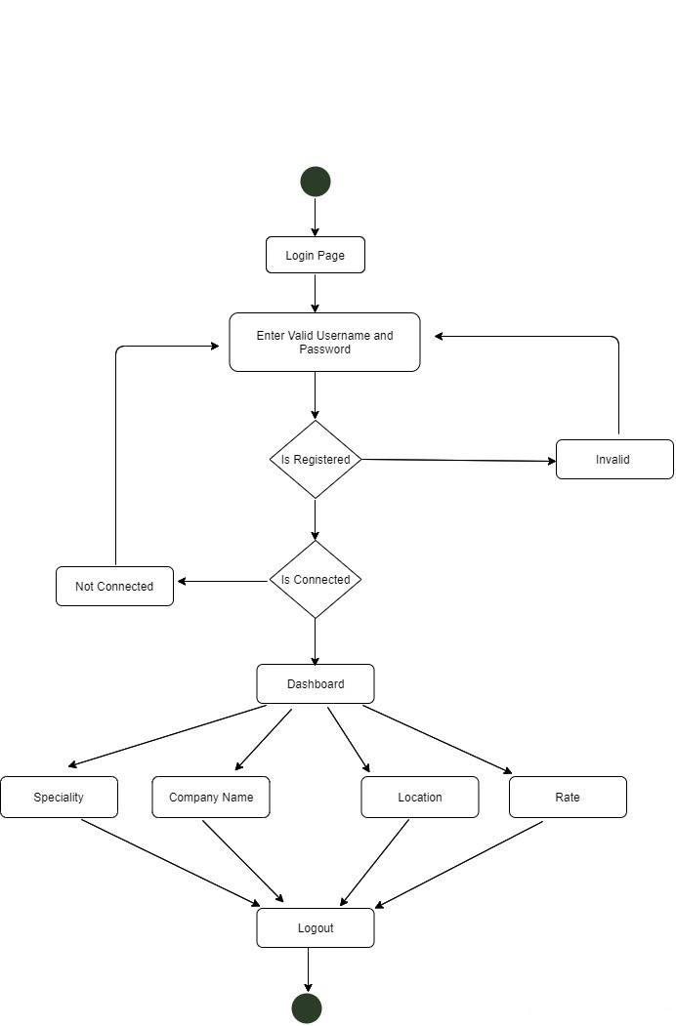

**Figure 4.3.1. Activity Diagram (Contractor)**

## 4.4. Design Models

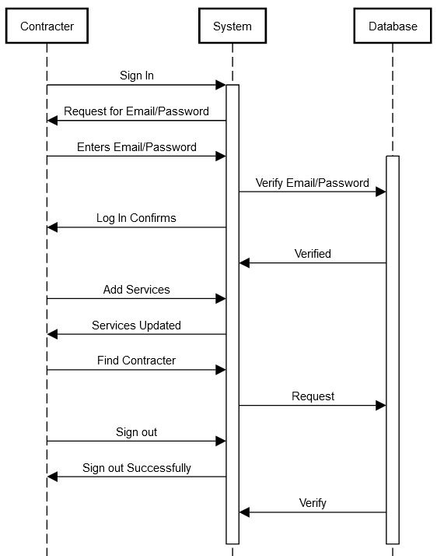

**Figure 4.4.1. Sequence Diagram (Contractor)**

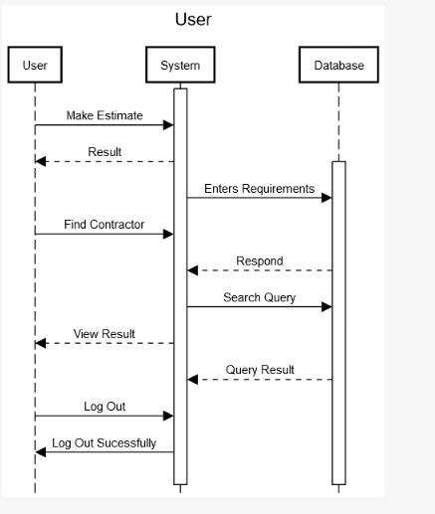

**Figure 4.4.2. Sequence Diagram (User)**